T-843 Antico Forno Colore Collection
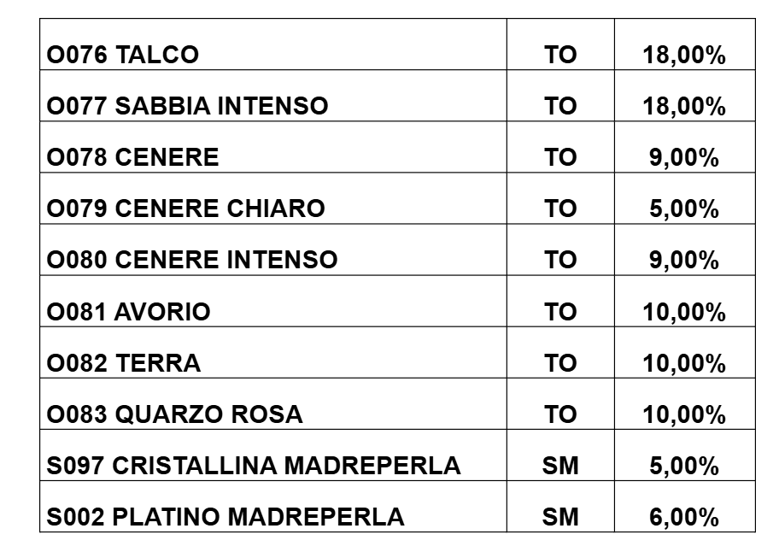
TRAPEZOID Mix Cipria 01 Color Composition

